Game overview

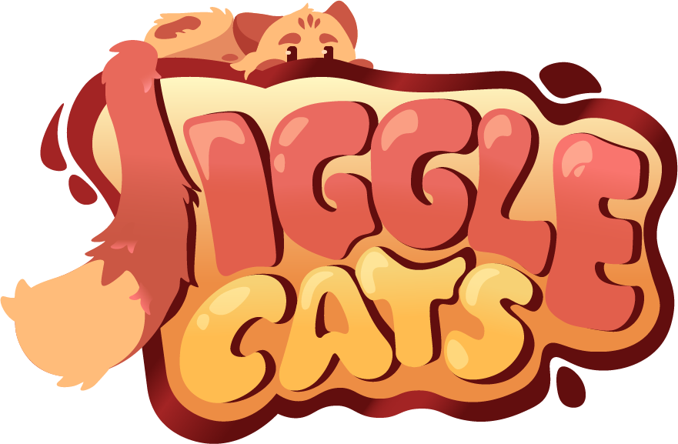

**Game title:** Jiggle Cats

**Platform:** Mobile

**Genre:** Endless side scroller

**Perspective:** 2.5D

**Core idea:** Proceed the auto speed level as a cat with 2 forms (Small, Big): Change between these forms to survive the obstacles in the level.

**Similar games:** Subway Surfers, Geometry Dash

**Target audience:** Mobile gamers, casual gamers

**Core Design Pillars**

**Challenging endless runner:** Increasing speed the further you get => fast reactions  
**Cute chaos:** Destroy buildings on your way as a cat

**Mechanics**

-Change the form of the character between 2 forms: 1 Big, 6 small ones.  
  
-Giga form  
Once you go through 10 obstacles, you can activate the giga form that lasts 10s. In giga mode you destroy buildings and get coins from them.  
  
-Automatic moving to the right  
  
-Power ups: Time slower, every form break walls  
Lasts 5-10s  
Time slower: More time to change the right form  
Destruction: Every form destroys every obstacle  
They appear in the level as 2 visually different objects, each one representing their own power  
Located in obstacles, so that there’s a challenge to get them.

**Rules**   
-If you make one mistake, the run ends. For example, you hit an obstacle with small form when you should have used a big form.

**Controls**

-Two buttons to change the form (left and right side of the screen).

**Features**

**Shop**  
**-**Two currencies: In-game currency (coins), Premium currency (gems)  
You get coins from the level. They spawn to the obstacles. You also get coins from destroying breakable buildings.  
-Skins  
-You can buy premium currency with real money and by watching ads

**Random generated level**  
**-**8 level components that spawn in random order  
-Ones with 1 possible way to go through but also ones with 2 possible ways.

**Jiggly cat**  
-Character has soft body physics

**Power ups**

**Destroyable buildings**  
**-**Comes when Giga mode is activated   
-You get coins from going through the buildings

**Meta Game**

Unlock new skins with both currencies

**Level Design**

The game has x number of components that spawn in random order. They are designed regarding on the 2 different forms. Some components are easier, requiring only 1 form to get through. Then there are harder components that require 1-2 forms to get through.

-Small form can fit through narrow gaps.   
-Big form can break through walls but won’t fit through narrow gaps.

Here’s some examples:

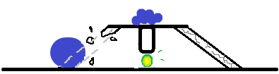  
*Here you have 2 options: With small form you don’t break the obstacle and continue your way to up.*  
*With big form you can break the obstacle and go through. Then you have to quickly change to small, so you won’t hit the obstacle, and then again to big, so you can break the other obstacle.*  
  
-------------------------------------------------------------------------  
  
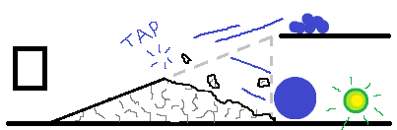  
*Here the long breakable obstacle can work as a ramp for the small form. If at any time on the obstacle you change to big, the obstacle breaks, and you go the lower way.*

**Art Style**

3D: Character, obstacles and destroyable buildings

2D: Parallax background

Character has soft body physics.

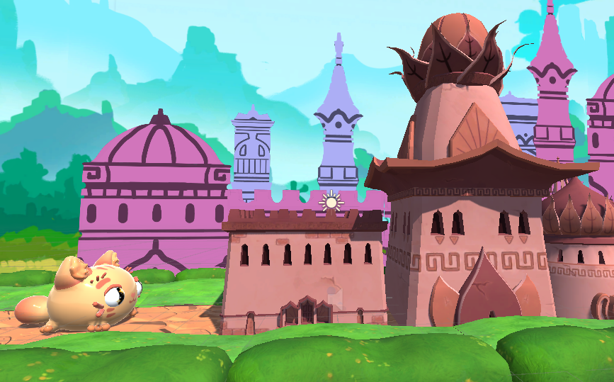  
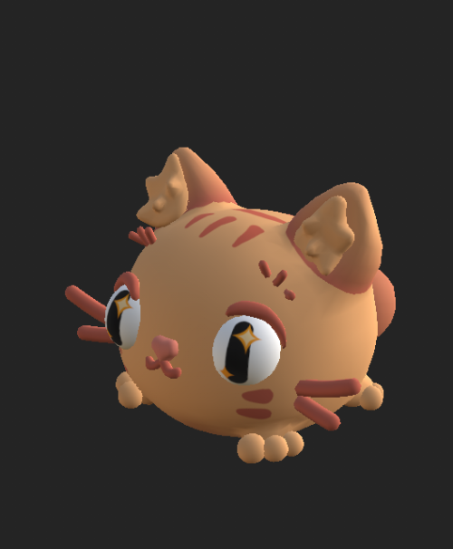  
The character

**UI**

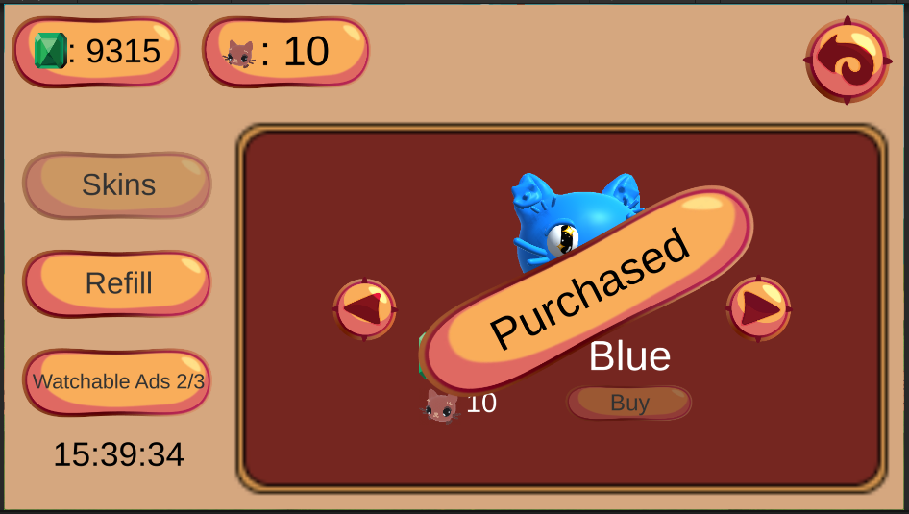  
Shop UI

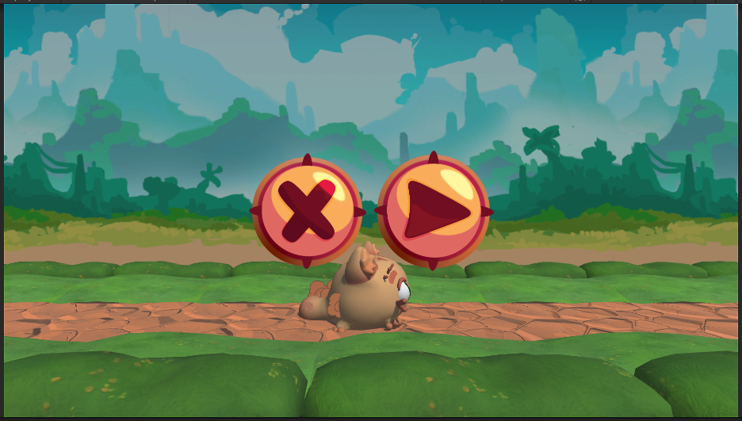  
Pause menu

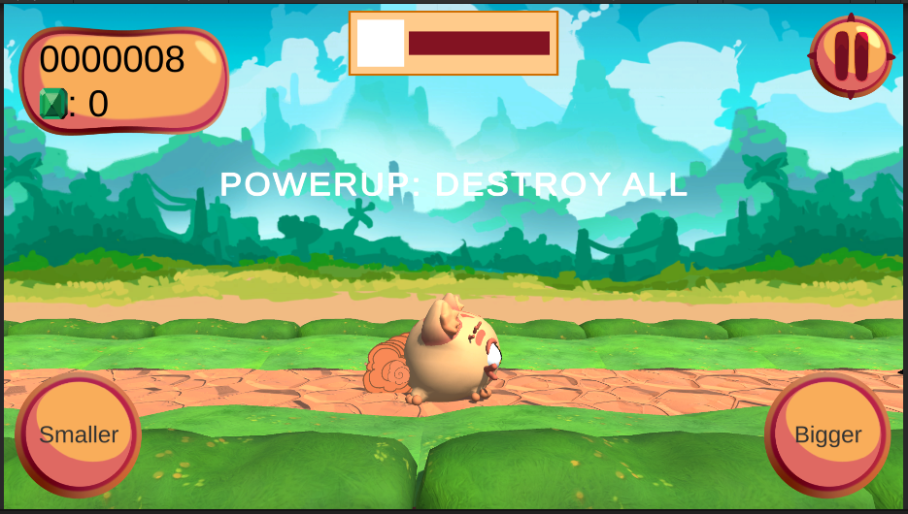  
In game UI